

Lab Experiment - 06
Vacuum Cleaner Problem

Aim
To implement the Vacuum Cleaner problem using a Simple Reflex Agent.

Objective
To clean all dirty rooms by sensing the environment and performing the appropriate action (Clean, Move Left, or Move Right).

Algorithm
- Start with the vacuum cleaner in the initial room.
- Sense the current room's status (Clean or Dirty).
- If the room is dirty, clean it.
- If the room is clean, move to the next room.
- Repeat the process until all rooms are clean.
- Display the actions performed by the vacuum cleaner.
- Stop.

FlowChart
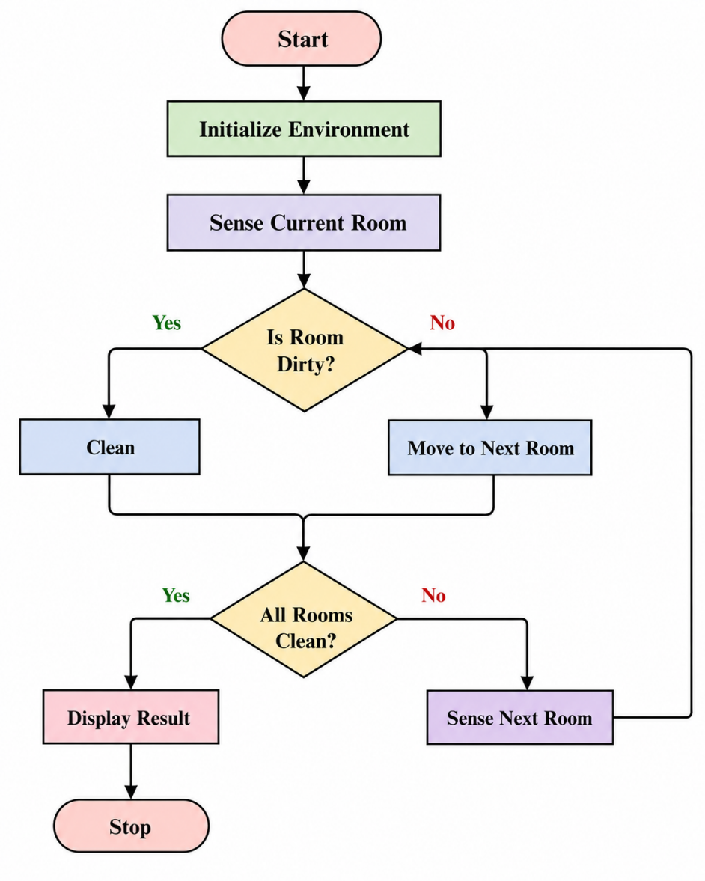
Code:
rooms = {'A': 'Dirty', 'B': 'Dirty'}

current_room = 'A'

while True:
print("Current Room:", current_room)
print("Status:", rooms[current_room])

if rooms[current_room] == 'Dirty':
print("Action: Clean")
rooms[current_room] = 'Clean'
else:
if current_room == 'A':
print("Action: Move Right")
current_room = 'B'
else:
print("Action: Move Left")
current_room = 'A'

if rooms['A'] == 'Clean' and rooms['B'] == 'Clean':
print("\nAll Rooms are Clean.")
break

print("Final Status:", rooms)
Output:
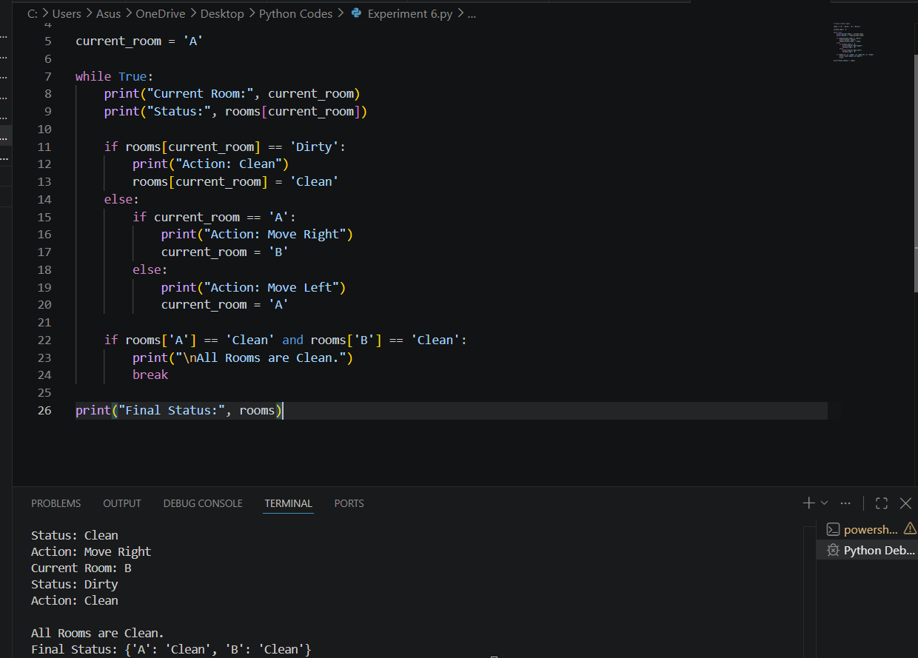

Result
The Vacuum Cleaner problem was implemented successfully using a Simple Reflex Agent.

Conclusion
The Simple Reflex Agent successfully senses the environment, cleans dirty rooms, and moves between rooms until all rooms are clean. This demonstrates the basic working of an intelligent agent in Artificial Intelligence.

